A000-Eur-France-Acheulian-Pick-250,000 BP

European Acheulian Lower Paleolithic (ca. 250,000 BP) pick from Le Grand Pressigny France

Perfect, no damage, ancient patination. Length: : 5.52 in (14.02 cm.); Width: 2.6 in (6.62 cm.).

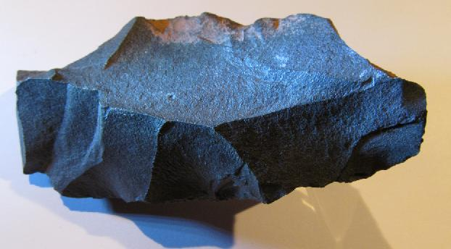

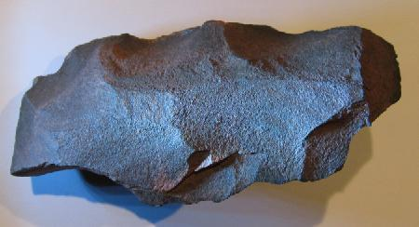

European Acheulian Lower Paleolithic (ca. 250,000 BP) rare robust elongated, trihedral pick of *Homo heidelbergensis* (*Homo erectus*), Le Grand-Pressigny, Southern Touraine, France

This European Acheulian pick was fashioned by Homo erectus, in the Acheulian method, the predominant tool technology of the Lower Paleolithic, ca. 250,000 years ago.  From an old French collection.

The Acheulian Tradition first began in Africa and there it is well-defined and most diverse when compared to other regions where it eventually diffused.  Although it developed in Africa, the industry is named after the type site of Saint Acheul, now a suburb of Amiens in northern France, where some of the first examples were identified in the 19th century. Acheulian tools are fashioned from large flakes as opposed to using a whole cobblestone as the core.

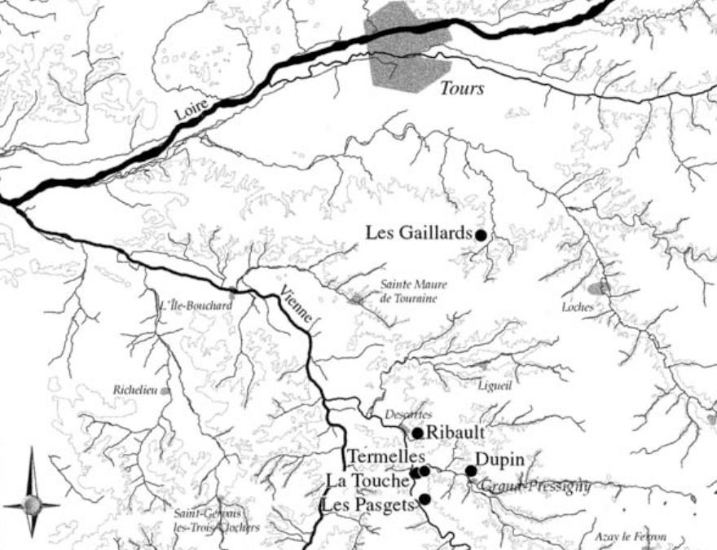

Map of Le Grand Pressigny area, France. After Primault J. 2003. Exploitation et diffusion des silex de la région du Grand-Pressigny au Paléolithique. Ph.D. diss., Université de Nanterre